**Response to Criticism**

Michelangelo was determined by the restorers to have worked in mainly *buon fresco*, with occasional small corrections *mezzo fresco* or *a secco*. As contemporary source Vasari says, secchi corrections are to be avoided whenever possible, and that though fresco artists did sometimes use tempera to retouch fresco, it was considered a cheap thing to do because it shortened the life of the work. [1] For all his grumbling, after so many years of effort, would Michelangelo really have used such transient material?

**Carbon Black?**

Michelangelo’s technique was determined by the Vatican’s restoration team to be a very light, dilute watercolor. The main figures were often articulated in much greater detail in contrast to their background figures and elements by using glazes and hatching, (i.e.) Ioel.[2] Tonal change was used as shading in some portions of the ceilings, but mostly backgrounds, but the majority of Michelangelo’s work was defined by color change, from warm to cool or an arbitrary change in color. This form of modeling, for a viewer at a distance, creates a blaze of color with very little shadow or darkness; in other words, very legible for a painting located in an oddly lit situation.[3]The brightness of color used by Michelangelo to depict the dynamic figures of the Sistine Chapel were a normal choice for the pigment-restricted fresco painter; Michelangelo’s teacher, Ghirlandaio, was himself known to use such a bright palette, and Michelangelo himself used a similar palette in the Doni Madonna he painted before his ceiling commission. [4] This predecessor shows some important insights into Michelangelo’s coloring schemes. Michelangelo appears to have created a base layer of solid color for the clothing of these figures, and then modeled the figures using color to create illusionistic form and texture.[5] Vasari complemented this piece on its dissonant colors which come together to make a unified image; as he said himself: “Unity in painting is a dissonance of diverse colours harmonized among themselves”.[6]

Those dark shadows that are noted by critics have been argued by others as past renovations. Many arguments for this case are based upon the texts of Condivi and Vasari, particularly the texts’ reference to the “*l’ultima mano*”, translated in two main ways: the “final layer” OR “final touches”. James Beck, art historian, was a well known supporter of this cause, his main evidence being that in another reference to final gold and ultramarine retouching to the ceiling, neither author made reference to the phrase “*l’ultima mano*”. What is overlooked is these passages are fairly sequential in nature, Beck himself stating that they are within 30 lines of one another. In this case, the two sections of texts could very well be seen as references to one another; in other words, the author is describing the same problem in two sections of the ceiling to show how Michelangelo suffered under the haste of the Pope. [7] This “*ultima mano*” was never reported to be applied.[8]

It lacked retouching with ultramarine *a secco* and in one or two places with gold, which would have made it appear richer. Julius, whose fervor had calmed down, wished Michelangelo to provide this; but Michelangelo, considering the bother that he would have in reassembling the scaffolding properly, replied that what was lacking was nothing of importance. –*Michelangelo: Life, Letters, and Poetry*, selected and trans. George Bull, Oxford and New York, 1987, 37-39. (Condivi)[9]

Michelangelo wanted to retouch some parts of the painting *a secco*, as the old masters had done on the scenes below, painting backgrounds, draperies, and skies in ultramarine, and in certain places adding ornamentation in gold, in order to enrich and height the visual impact. The Pope, learning this ornamentation was lacking, and hearing the work praised so enthusiastically by all who saw it, wanted him to go ahead. However, he lacked the patience to rebuild the scaffolding and so the ceiling stayed as it was. His holiness used to see Michelangelo often and he would ask him to have the chapel enriched with colours and gold, since it looked impoverished. And Michelangelo would answer familiarly: ’Holy Father, in those days mean did not bedeck themselves in gold and those you see painted there were never very rich. They were holy men who despised riches.’ –Giorgio Vasari, *Lives of the Artists*, trans. G Bull, London, 1965, I, 351-354 $[10]

Hartt, another notable art historian, emphasizes that the layer of glue was added “’*over* the restorations to the *Sacrifice of Noah* carried out by Domenico Carnevali between 1566 and 1571,’” which had been necessary due to the cracking of the plaster as noted by Paolo Giovo in 1547.[11] Indeed, evidence has shown that many overpaintings, *a secco*, were painted in by later restorations in hopes to make the famous paintings, obscured by the dark glaze of soot and glue, more recognizable and distinct. Many of these darker overpaintings have heavy parallel brushstrokes, a deliberate difference between that artist’s hand and the master’s. These are often attributed to Mazzuoli during his restoration, hoping to increase the legibility of the ceiling.[12] Later restorers less refined, emphasizing the chiaroscuro to the point that Michelangelo’s original light scheme was completely; whether one believes that the frescoes existed clean and colorful to the world or varnished and shaded with lampblack, it is still evident that the difference in value of the draperies of Michelangelo’s characters was not as dramatic as later overpainting made it seem. This overpainting got to a point that the sky above Zechariah’s throne had no discernable color, only revealed by the cleaning to later be full smalt blue.[13]

Another interesting point noted by the restoration team was Michelangelo’s use of different intonacos, the layer of plaster on which Michelangelo painted. It is fairly noticeable that the intonaco, and therefore its color, varies from scene to scene across the ceiling and lunettes. There are three types spread over the chapel, with:

* + dark inclusions of lamellar shape and vitreous aspect (thin, plate-like pieces with glass like qualities)
  + large reddish brown scoriae with a tufaceous aspect (porous, limestone like volcanic rock)
  + a mixture of the two [14]

As explained above, Michelangelo’s technique involved using a very dilute water color. In addition, certain groups across the ceiling all share the same type of intonaco, regardless of their proximity to each other, and therefore Michelangelo’s chronological passage: (i.e.) all the ignudi are comprised of the vitreous intonaco. The restorers thus made the reasonable assumption that the intonaco selection was not a simple one of convenience but rather one of artistic choice.[15] In this case, would a use of lampblack, partially obscuring the color of the paint and most assuredly obscuring the coloring of the intonaco, really be likely?

Tests completed by the restoration team have also supported the theory that no final glue or lampblack layer was completed. From the outside surface in to the intonaco, the foreign materials as discovered by the team are:

* + silicic dust particles
  + lamp black with long chain fatty acids
  + gum resin (gum Arabic type)
  + lamp black with long chain fatty acids
  + repaintings from previous restorations
  + animal protein (glue) and linseed oil
  + lamp-black and silicic particles on surface of original intonaco[16]

Airborne pollution of soot and grease had been a continual problem for the frescoes before the restoration’s drastic climate control plan; even just six years after the completion of the ceiling, a special team was charged with cleaning the frescoes.[17] In addition, the salt efflorescence outbreaks that plagued Michelangelo even as he painted continued on as the vault of the roof continued to leak. However, this plague can also be used to help prove a point: the areas of repair must postdate Michelangelo, because the efflorescences of salt are *behind* these layers. If one thinks about the situation, the efflorescences were painted over with glue specifically so they could not be seen. Any new efflorescences of salt, as reported by countless restorers, would have to have broken through Michelangelo’s supposed varnish is order to be varnished over again.[18]

Finally, Michelangelo should be recognized as a purist in terms of technique. After discovering that non fresco pigments were destroyed due to water leakage in the vault in his earliest frescoes, including the flood, it seems very unlikely that Michelangelo would continue this kind of experimentation. Copper greens and blues were omitted from all but his first paintings, indicating he realized the transitory nature of those pigments relative to the eternal fresco pigments.[19] There is no evidence of any fresco artist creating a “patina”, or deliberate over wash of color or tone, at the time of the Sistine Chapel, and indeed, Vasari warned that glazes were impractical to use over fresco because they would quickly become opaque, thus hiding Michelangelo’s modeling.[20]

**Cleaning Method**

The cleaning method for the Sistine ceiling was originally tested on another Sistine chapel fresco: Matteo da Lecce’s “Dispute over Moses’ Body”[21] The solvent, AB 57, a twenty year strong tradition made of bicarbonate of sodium and ammonium and an antibacterial and antifungal agent, all suspended in carboxymethylcellulose and water (forming a gel), allows the conservators control over application and ensures that there is no dripping.[22]

The restoration team made use of computer mapping technology as well as ultraviolet and infrared photography and many other tests, including tiny samples of the surface, to produce useful diagrams of the frescoes showing surface heights, irregular absorption of lights, and other important details[23]. In this way, they were able to identify the raised areas of potential *a secco* alterations. No cleaning was done until all parts painted *a secco* were identified as well as pigments that were “detached” or “desquamated”, which were reattached by means of an emulsion called Primal AC 33. These were all then waterproofed or “fixed” by use of an acrylic resin, Acryloid b72, diluted by potassium nitrate thinner. Only after every potential *a secco* addition determined to be by Michelangelo’s hand or of an indeterminate origin was protected did the cleaning begin.[24]

The cleaning was a gentle process done in stages, using natural sponge ( in place of cotton due to cotton’s greater abrasiveness) to first wipe down the area to be cleaned with distilled and deionized water, taking care to avoid the waterproofed areas as a safety precaution. After this, the solvent was applied, allowed to sit for 3-4 minutes, and rinsed off several times with the water. If the area was determined to need additional cleaning, then the process would be repeated after 24 hours of rest. In rare cases where the area was so soiled it required a third cleansing, a rest period of 1-2 weeks was administered before the third cleaning occurred. The salts were also eliminated by careful application of the AB 57 solvent with an added component of EDTA in many stages, until the salts were completely dissolved.[25]

The *a secco* sections were also cleaned by alternating potassium nitrate thinner (to dissolve a small layer of the waterproofing resin originally applied) and solvent mixture in thin layers. In each case, the thinner or solvent was applied then wiped away very quickly with water, in order to prevent anything from soaking in (the C-80 method). The resin thus remained embedded in the pigment, protecting it from the solvent, but the dirt was exposed and wiped away. By the end of the process, the resin was removed, excepting a small amount to fix the pigments[26]

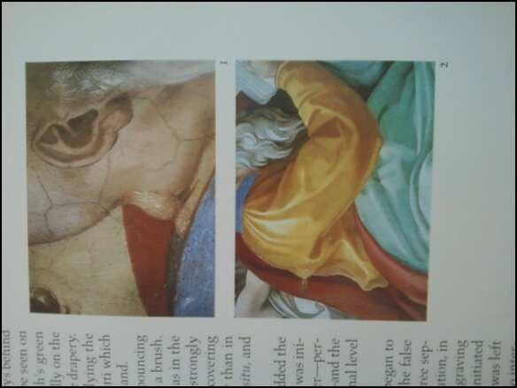

Preserved pentimenti on the prophet Zechariah, as seen in the official report of the restoration team.

**Color**

The effectiveness of color as modeling is a matter for personal debate. As referenced in the criticism above, some believe that the use of color as shade is not effective enough and that Michelangelo must have intended to overpaint, while others believe the use of bright color was an intentional device to counteract the difficult lighting situation of the ceiling, particularly the lunettes.

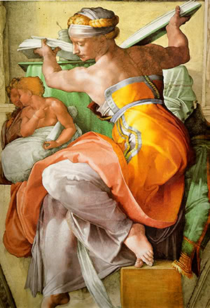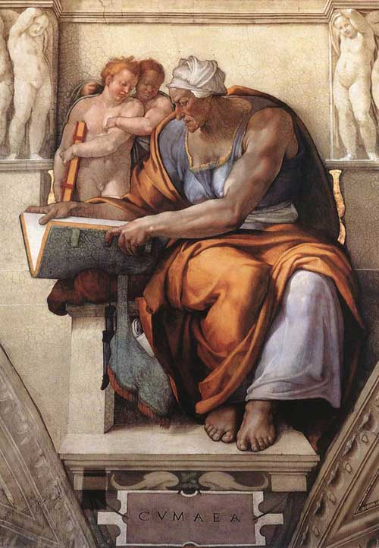

The two sibyls mentioned above in the criticism are here pictured. While the Cumean sibyl (on the right) is undoubtedly swarthier in complexion versus the Libyan sibyl, one can see that her robes are modeled in much the same way, a deep mustard yellow that progresses into a dark orange and eventually into a brownish black. Even the lace on her bodice neckline follows a changeant color technique: goldenrod exists side by side with a greyish green.



**Eyes**

Another hot issue of debate was the eyes of several lunette figures, which were overpainted in black. This is thought to have been done in order to increase the legibility of the figures from a distance, as the darkness of the glue eventually made it difficult for viewers to determine faces. [27]On close inspection of the Jesse spandrel’s figure before restoration, in a high resolution image such as those available on ARTstor, one can clearly see the parallel hatching of lines that make up the irises of his eyes. This painting technique is attributed to Mazzuoli’s restoration, as noted above. Other lunettes which “lost their eyes”, such as the Zorobabel and Aminadab lunettes, had nothing more than crudely darkened eye sockets and occasionally irregular indications of irises before the restoration.

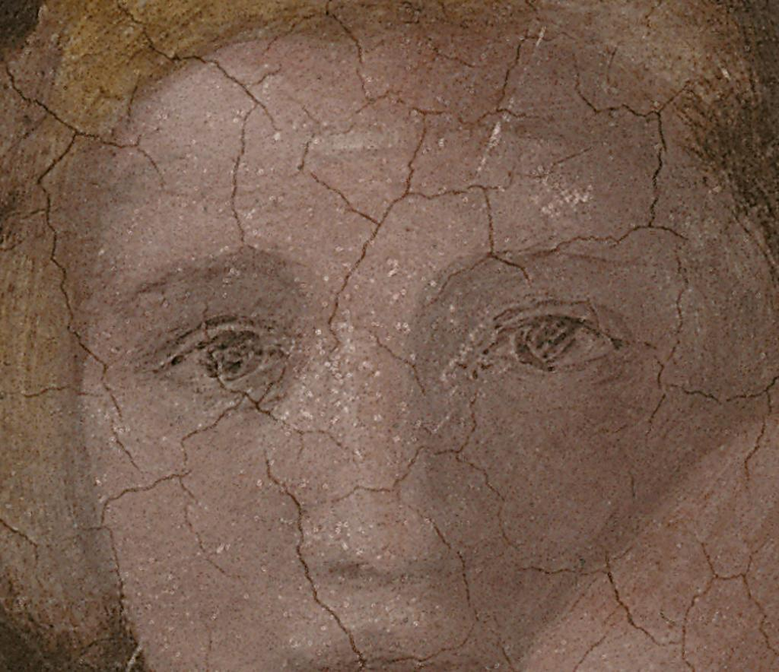

It was well known that previous visitors had complained of the darkness and illegibility of the frescoes (Goethe, a visitor is 1787 complained that they were “blackened” and predicted their disappearance under filth soon)[28], and that previous restorations had darkened the figures in an attempt to clarify. The varnishes used to protect these repaints darkened itself as well as oil used, which seeped into cracks of the ceiling and darkened there. These necessitated further work, in a vicious cycle. There were two certain interventions of which the renovator can be identified, Carnevali’s in 1570, done almost entirely in fresco, and Mazzuoli’s in 1710, done almost entirely in tempera. [29] Some restorers in the past went as far as to correct Michelangelo’s work, as in Zacharias, who was found to have been enlarged, simplified, and further developed in contrast. One could even see the pencil lines he sketched with before completing his change. [30]

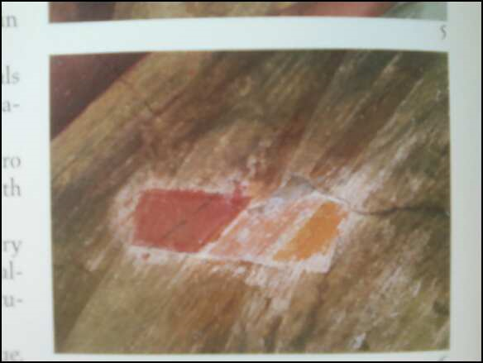

The glue and paint cleaned away from the robe of Zacharias; one can see the pencil mark made by a past restorer on the red paint surface. (*)

Last but not least, the reason the Vatican called for this restoration was not a decision of vanity, but rather a crisis. The glue applied in so many layers to the surface of the fresco has continually contracted for hundreds of years, and it is finally threatening the surface by literally peeling away the intonaco plaster, which carries the pigments, from its base.[31]

1. Cast, David. “Finishing the Sistine”..
2. Mancinelli, 46.
3. Steinberg, Leo. “A New Michelangelo.”*Art & Antiques*. (1985). Print., 93.
4. Brandt, Kathleen Weil-Garris. “Twenty-five Questions about Michelangelo’s Sistine Ceiling.” *Apollo*. December (1987): 392-400. Print., 398.
5. Buzzegoli, Ezio. “Michelangelo as a Colourist, Revealed in the Conservation of the Doni Tondo.” *Apollo*. December (1987): 407-408. Print., 408.
6. Buzzegoli, 407.
7. Beck, James. “The Final Layer: ‘*L’ultima mano*’ on Michelangelo’s Sistine Ceiling.” *Art Bulletin.* Vol 70, No. 3 Sep 1988, 502-503.
8. Brandt, 398.
9. Cast.
10. Cast
11. Cast, 672.
12. Mancinelli, 229.
13. Mancinelli, 228.
14. Mancinelli, 247.
15. Mancinelli, 371.
16. Mancinelli, 247.
17. Brandt, 398.
18. Brandt, 398.
19. Mancinelli, 370.
20. Brandt, 395.
21. Mancinelli, Fabrizio, and Gianluigi Colalucci. *Michelangelo, the Sistine Chapel: Report on the*

    *restoration*. Vol. 1. Vatican City: Canova, 2001. Print. 2 vols. , 203.
22. Jeffery, David. “A Renaissance for Michaelangelo”. National Geographic. December (1989). Print., 697.
23. Jeffery, 698.
24. Mancinelli, 205.
25. Mancinelli, 205.
26. Mancinelli, 207.
27. Mancinelli, 255.
28. Brandt.
29. Mancinelli, 202.
30. Mancinelli, 227.
31. Brandt.